Triton Logger:

Under tools pull down go down to log and then click “Start Logger”.
It will ask you to Continue from a previous logfile or create a new log.
If yes select a file a pop up menu will open and then go to the directory of the logfile. The file should be a .xls file. (picking a logfile will automatically load the effort species stored in the logfile)
If “create new log” is selected a pop up menu will open up then choose a directory you want to save the file in.
Then a list of species and groups will appear.
Clicking on the species will put a check mark on it and will appear in the effort section of your log file
You can also select the species’ group to select all the species in that group.
Once you have selected all the species you wanted click the “Effort” button to finish.
The logger will then ask to select a start time (you cannot select a time from the Timeseries)
You can also click “Load Effort” and select an effort logfile or previously made logfile.
You can click “Save Effort” to save the effort so the same effort log can be used again for a new logfile.
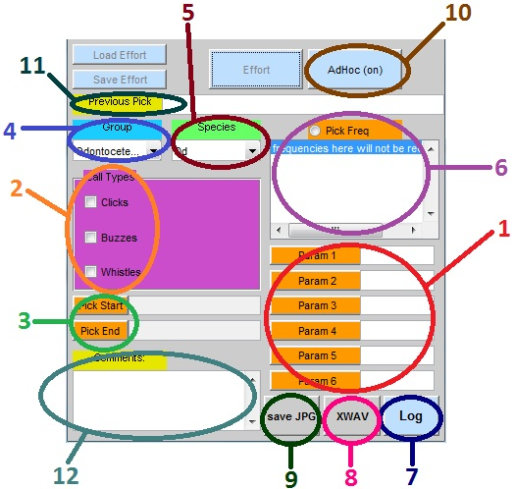
Here is an example after you have a logfile open:

- Parameters: these consist of parameters that are associated to the call type currently selected. If no Parameters are specified in the template there will be a default of 6 Param buttons. To use: simply click on the Param button you want to store the info in or use the hotkey: numbers 1-6.
- Call Types: This section displays the Call types associated with the specified species(5). Clicking on a call type will put a checkmark (or uncheck if it was already checked) on the call. The Param(1) section will then be updated to display the Call Type’s specific Parameters if it has any. Note: selecting a new call type updates the Param(1) section, you will not be able to change the previous params as clicking on a checked call type will uncheck it and reset all the values in the params.
- Pick Start/End: This records the start and end time of a frequency being recorded. To use: Click the “Pick Start” button to record the start time. Then click the “Pick End” button to record the end time. You can also use the hotkey: “S” for Pick Start and “E” for Pick End.
- Group: Displays the groups that were selected in a drop down tab. Selecting one will update the species and call Types section.
- Species: Displays the species that were selected in a drop down tab. The species available is according to the Groups selected. Selecting one will update the call Types section.
- Pick Freq: this displays the frequencies this allows you to preview the frequency before you select it for your params. To use: click on the Pick Freq button (or press the hotkey: “F”) to toggle the function on and off. The mouse selector will turn into crosshairs on the Plot window when Pick Freq is on.
- Log: After you have picked all the data you wanted to press “Log” to save the data onto the logfile. The following fields need to be filled before logging data into the logfile: CallType, Pick Start/End.
- XWAV: this saves the current Plot Length as an XWAV. A window will open up and will ask you to choose a directory to save the wav file.
- Save JPG: this saves the current display in the Plot window as a .jpg image. A window will open up and will ask you to choose a directory to save the .jpg image.
- AdHoc: the AdHoc function is used to input log data for calltypes that are not in the current effort selection. Turning adhoc on will turn the background of logger to red, to turn it off press the “adhoc (off)” button, the background will revert back to its normal gray color after to indicate normal functions. While in adhoc mode all the groups species and calltypes that are written in the logger template will be available. Logging in data will save the logs in the adhoc section.
- Previous Pick: after Logging data into the logfile all the fields will clear and the newly added log will appear in Previous Pick.
- Comments: Use this section to write down any comments you might have for this particular data.

Set up a logging template:

Search in your triton folder. In that folder you can find a folder named “log_data”. This is where you put your template.
To make a new template open excel and make a new .xls sheet (you need Microsoft excel to make a new file).
2 tabs are needed: Detection and Project. Detection will be where all the species and call types
The first row needs to be the topics. To view the category in the logger type in “(read)” to use the category so that it will be written into the logfile type in “(write)”
There needs to be at least 3 “(read)” categories and as many “(write)” categories as “(read)” categories.

